\Solenoid Valve Option:

<https://www.digikey.com/en/products/detail/adafruit-industries-llc/997/6827136>

Datasheet: <https://mm.digikey.com/Volume0/opasdata/d220001/medias/docus/2554/997_Web.pdf>

Cost: $6.95

-Threaded 1/2" NPS Connection Method

-So we would need some sort of piping with the correct connector on the end

-ETG said they have piping we can use, but I’m not sure if it comes with specific connectors or not, I would guess probably not.

-Worth asking

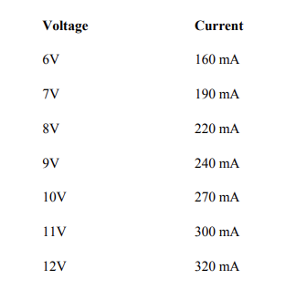

-Requires a flyback diode

-Datasheet provides specific NMOS and diode recommendations

-Appears to be the cheapest in-stock normally-closed solenoid valve for liquids on DigiKey:

[Specific DigiKey Search For This Product](https://www.digikey.com/en/products/filter/pneumatics-hydraulics/valves-and-control/809?s=N4IgjCBcpmAMVQGMoDMCGAbAzgUwDQgD2UA2iACwBsATFQBwSHV300iFgDMA7AKy8O4XgPpCw9OHR4gAuoQAOAFyggAykoBOASwB2AcxABfTjx5dEIFJAw4CxMiC5U%2BNOFSFc%2B9KlQuEuMBoKLgR5EGVVDR0DY0IAWnZoKygtAFd7EkhyPjkjExAPZO0AE1V4%2BCYIlUgQISUATwVcVXRsFHygA)

-We probably want to have a normally-closed valve so that if power is lost, the water is still contained and not automatically poured into the soil. (Assuming the water will be suspended above the soil and use gravity to dispense)

-The valve is fine, but how are we going to distribute the water evenly around the soil? We prob don’t want like a super wet spot and have the rest of the soil be dry.

Option 2: Drip Irrigation

Example: [Amazon Kit 1](https://www.amazon.com/HIRALIY-Irrigation-Distribution-Automatic-Greenhouse/dp/B0819F4YF5/ref=sr_1_1_sspa?adgrpid=1341404757743402&dib=eyJ2IjoiMSJ9.3JbeqfFa_G2OlfcnNqD7hfyEgMQYBDxKtsojE9U3Uydfkjxl7XQZL781MyUuk7jZI-DH5AvufdHySOEwgZVt32hAh17T1ePSrFL6pRjjuUiO7TvF8mF9JG1lvY6tb61VQgTyY7F0QOwceLWn8qPvWGkYQxbzh7I-qo0h89GZHJNV7fa0zC4DmWx4sbktquNe4sU0ASJ2cyu0ZKhRU-oSTh3LBqtD0JXNGvjrBR6fJLDEGpe0Ep6GDsh4woru9X64CEKk3DC6kbCoHjv7PPguxZyZVWJ0SubNr02QZUcc68U.mHKuPGWCW_dk6tc_XbF-TgG28Pic_4idy_5r8EbqOQs&dib_tag=se&hvadid=83837869567286&hvbmt=be&hvdev=c&hvlocphy=102474&hvnetw=o&hvqmt=e&hvtargid=kwd-83838157284646%3Aloc-190&hydadcr=24656_10676145&keywords=drip%2Birrigation%2Bkit&qid=1710734389&sr=8-1-spons&sp_csd=d2lkZ2V0TmFtZT1zcF9hdGY&th=1)

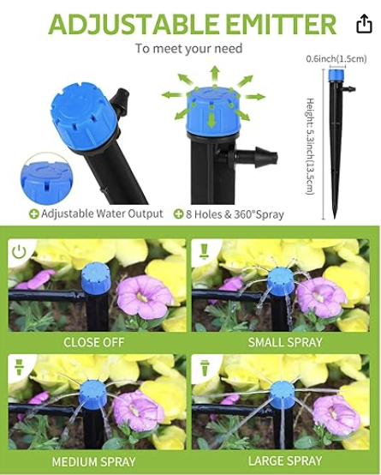

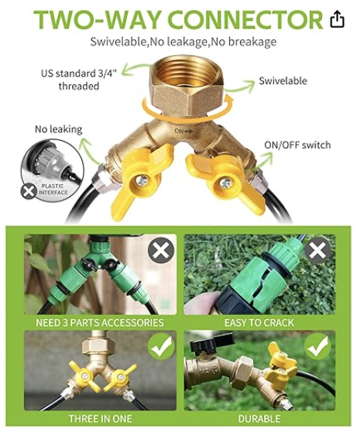

-So maybe if we just match up the connectors for a kit / system like this with the solenoid valve we could easily control watering.

-Should compare implementation pros and cons of a system that works like this vs something suspended or above the plant.

[Amazon Kit 2](https://www.amazon.com/Garden-Irrigation-Automatic-Equipment-Greenhouse/dp/B0CWG6R74S/ref=sr_1_10?adgrpid=1341404757743402&dib=eyJ2IjoiMSJ9.3JbeqfFa_G2OlfcnNqD7hfyEgMQYBDxKtsojE9U3Uydfkjxl7XQZL781MyUuk7jZI-DH5AvufdHySOEwgZVt32hAh17T1ePSrFL6pRjjuUiO7TvF8mF9JG1lvY6tb61VQgTyY7F0QOwceLWn8qPvWGkYQxbzh7I-qo0h89GZHJNV7fa0zC4DmWx4sbktquNe4sU0ASJ2cyu0ZKhRU-oSTh3LBqtD0JXNGvjrBR6fJLDEGpe0Ep6GDsh4woru9X64CEKk3DC6kbCoHjv7PPguxZyZVWJ0SubNr02QZUcc68U.mHKuPGWCW_dk6tc_XbF-TgG28Pic_4idy_5r8EbqOQs&dib_tag=se&hvadid=83837869567286&hvbmt=be&hvdev=c&hvlocphy=102474&hvnetw=o&hvqmt=e&hvtargid=kwd-83838157284646%3Aloc-190&hydadcr=24656_10676145&keywords=drip+irrigation+kit&qid=1710734389&sr=8-10)

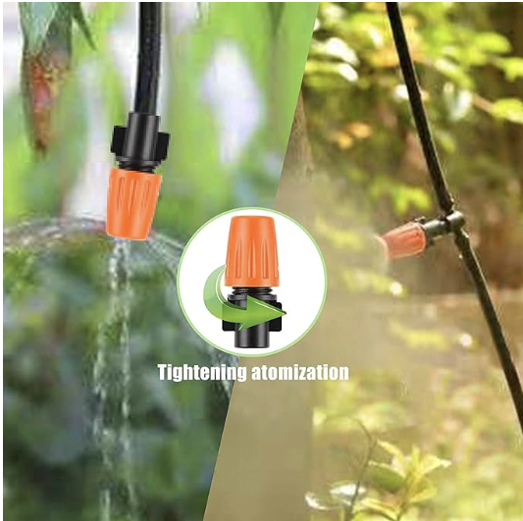

-So this dripper is adjustable in how it dispenses water (on top of water flow strength being controlled by another component in the system).

-Does the method of watering matter, like misting or just straight water?

-Apparently it’s ideal to water as close to the root as possible and avoid getting water on leaves. So something like misting probably wouldn’t be a great idea.

-I guess a worry would be how we would produce enough water pressure.***

-Maybe just have the soil end of the valve go directly into the sprayer thing and still use gravity? I think we’d prob want one to more evenly distribute the water around the soil.

-How would we ensure the water would be high enough relative to the soil?

[Amazon Kit 3: Best](https://www.amazon.com/HIRALIY-Quick-Connect-Irrigation-Adjustable-Fan-Shaped/dp/B0C1C2PPH5/ref=dealz_this_d_sccl_4_1/139-5779354-0263213?pd_rd_w=WLmEL&content-id=amzn1.sym.62d2b14c-b486-4c72-ac1b-0f459a3aae46&pf_rd_p=62d2b14c-b486-4c72-ac1b-0f459a3aae46&pf_rd_r=VM0P4PQT0C15G92TCX3J&pd_rd_wg=oEio8&pd_rd_r=942eca55-7a4a-47bb-aad5-c1bb55ca6572&pd_rd_i=B0C1C2PPH5&th=1)

-360 degree spray, better than the 8-direction option.

-Uses 1/4in tubing.

-Relatively cheap

[Specific Ideal Dripper](https://www.amazon.com/dp/B0BWF7MK6K/ref=sspa_dk_detail_6?pd_rd_i=B0BWF7MK6K&pd_rd_w=jT8Po&content-id=amzn1.sym.386c274b-4bfe-4421-9052-a1a56db557ab&pf_rd_p=386c274b-4bfe-4421-9052-a1a56db557ab&pf_rd_r=4P243NNRGYWTVTD02806&pd_rd_wg=EuR6s&pd_rd_r=b3f5f1c8-5955-4fe7-8b05-dcbe2c782ec2&s=industrial&sp_csd=d2lkZ2V0TmFtZT1zcF9kZXRhaWxfdGhlbWF0aWM&th=1)

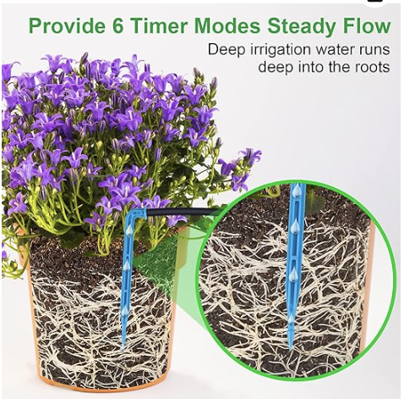

-Goes directly into the soil near the roots which is the best possible watering condition

-Water goes downwards, so if we use a gravity approach it would be easier

[Ideal Dripper (no pump)](https://www.amazon.com/Drip-Irrigation-Kit-Anti-Siphoning-Accessories/dp/B0BJDX195H/ref=pd_bxgy_d_sccl_1/139-5779354-0263213?pd_rd_w=t92PZ&content-id=amzn1.sym.9713b09e-9eac-42a7-88bb-ecfe516a6b92&pf_rd_p=9713b09e-9eac-42a7-88bb-ecfe516a6b92&pf_rd_r=S2EBCVPFNK1F0CYEGNH4&pd_rd_wg=r81ZX&pd_rd_r=515fa5d9-ee64-4ab7-ad92-fe5e531f2663&pd_rd_i=B0BJDX195H&th=1)

-So if we use this distribution system, maybe we could do something that’s like an electrically activated pump rather than just a valve.

-How would liquid fertilizer work with this system?***

-What are ideal fertilizer conditions? Directly into the soil like this?

Separate Pump Option:

[Pump Option 1](https://www.amazon.com/Ulka-EX5-Vibratory-Pump-Dramatically/dp/B00B8KBVZE/ref=sr_1_2?crid=3V3MPVLUFSBDO&dib=eyJ2IjoiMSJ9.MhXvKqtg_EIcr-h3vs7gSHBuJvBZ8Keiupqas9P2vfX6kE-VF0sgpGDTbz3rSTCvQtW47jCvUJKoTxCa3OqdvolKLO1Vzc23nWDSoO0r6qlz99E7Dpe30Kw3gGKxnqv95gAxA_C4klIf1tM5vjA8meQvbNv7sCEQw7sVM7JIoMQFNeE0TPiRVStdo8qWeMVapzBn0nYTkb1pP97Lcl6yV6OdgVpt3BTYwp30fnzxBnM.4xGmAd03-XITW-z-A8MZ4KrUeidiGbENupREy6J8HhA&dib_tag=se&keywords=solenoid+pump&qid=1710777675&sprefix=solenoid+pump%2Caps%2C106&sr=8-2)

-Apparently used in espresso machines???

-Relatively cheap

-Uses 1/8in diameter though

-We could go with the base kit maybe since it’s $40, but if we do that we wouldn’t be able to control the flow of water directly ourselves unless we sorta hacked it. Which could be doable maybe?

-The separate espresso machine pump with the piping / dispensers total would be $30 and we could control it ourselves more easily.

Pot Setup:

-Left: Water Dripper

-Right: Fertilizer Dripper

-Top: NPK Sensor

-Bottom: Moisture Sensor

-We don’t want the pot to get overcrowded with probes and devices, so we probably want to get “all in one” kind of sensors.

Primary Questions:

1. Pump or no pump to address the issue of water pressure?
   1. If no pump, how will we suspend the water container higher than the soil? Similarly, what about the liquid fertilizer?

—----------------------------

3/28

-New order form

-Water dispenser

-RS485 converter for Pi Pico

<https://www.amazon.com/Reciprocal-Hardware-Automatic-Control-Converter/dp/B0CKSDF6ZP/ref=sr_1_4?crid=16M1QZQ09O35F&dib=eyJ2IjoiMSJ9.vaQKXXGuFNgpjjpDHyz0v9hOSAgZzK0B92yARLIJZ8On-MeAykjl0FTfpoVcx0ecHw44Qanu8i9aOyWcuHM4uaOhrUKwjHEtptYeCqoA5fwVk3rgUip1Npqy79CLhjhBm4vsm8ITP8dhHAmLq514hwYrpoDoYo1b_d1m7D-5Ebi4Sb6T_578O99z4W2CfnkpqpH460TuZ2-5WbygvCr8v2Rq9J4rHqG-WRCs5FqRKgpcIVzjKjxjVkTIrWKO5b1uH-3KbdueowYGrhzhb83DZlnWo_U_iThUPMvzLav9QrI.65P5Jv5WIwOVha8oVmFY_Y8Uh9El0DnnDggX2zFsKcg&dib_tag=se&keywords=rs485+to+uart&qid=1711647366&s=electronics&sprefix=rs485+to+uart%2Celectronics%2C124&sr=1-4>

<https://www.amazon.com/Drip-Irrigation-Kit-Anti-Siphoning-Accessories/dp/B0BJDX195H/ref=pd_bxgy_d_sccl_1/139-5779354-0263213?pd_rd_w=t92PZ&content-id=amzn1.sym.9713b09e-9eac-42a7-88bb-ecfe516a6b92&pf_rd_p=9713b09e-9eac-42a7-88bb-ecfe516a6b92&pf_rd_r=S2EBCVPFNK1F0CYEGNH4&pd_rd_wg=r81ZX&pd_rd_r=515fa5d9-ee64-4ab7-ad92-fe5e531f2663&pd_rd_i=B0BJDX195H&th=1>